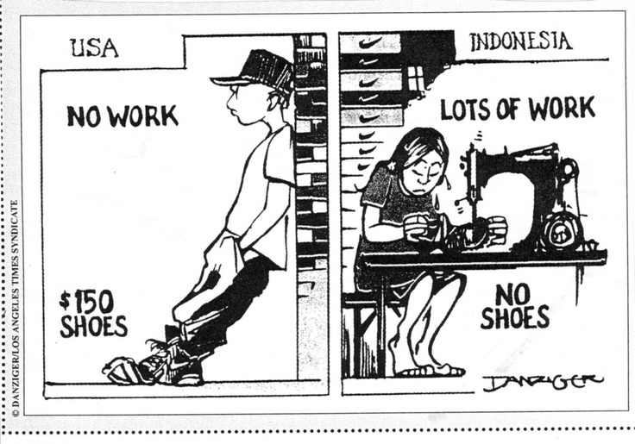
What are the Pros/Cons of Globalization?
- Improves the global Economy
Business owners benefit by having access to a bigger market for their goods and services.
Customer also benefit from the lower price of the goods and services.
- Globalization can lift people out of poverty
Globalization has increased job opportunities in developing countries. But the jobs differ in terms of the quality.
- Countries are becoming closer (strengthen the ties between countries)
People are being exposed to the culture, attitudes and values of people in other countries.
- Information spread more easily with the help of globalization
Countries can look to other countries for inspiration
A good example for the inspiration of other countries is the rise of mobile banking in Kenya.

Cons:
- Makes the Rich, Richer
Owners and managers benefit from globalisation. Workers are often being exploited by the rich companies.
- Loss of Culture
Globalisation might lead to cultural homogeneity. Imagine everyone wearing jeans and watching hollywood movies. We would lose a lot of precious cultural practices.
- Small businesses also suffer from globalisation
Local competitors are physically unable to match those low prices due to the lack of an outsourcing infrastructure, and wipe them out with a pricing war
